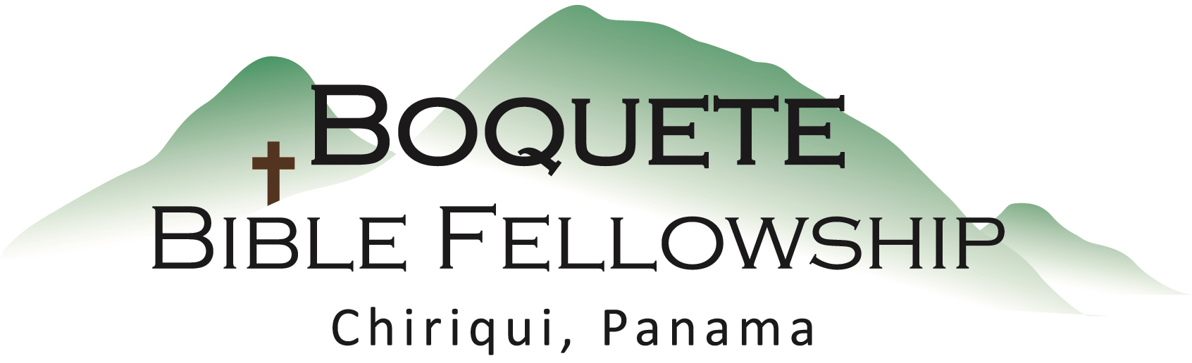

And behold, the curtain of the temple was torn in two, from top to bottom. And the earth shook, and the rocks were split. ⁵² The tombs also were opened. And many bodies of the saints who had fallen asleep were raised, ⁵³ and coming out of the tombs after His resurrection they went into the holy city and appeared to many. – Matthew 27:51-53 (ESV)

Jesus said to him, “I am the way, the truth, and the life. No one comes to the Father except through Me.” – John 14:6 (NKJV)

Therefore, brothers, since we have confidence to enter the holy places by the blood of Jesus, ²⁰ by the new and living way that He opened for us through the curtain, that is, through His flesh, ²¹ and since we have a great Priest over the house of God, ²² let us draw near with a true heart in full assurance of faith, with our hearts sprinkled clean from an evil conscience and our bodies washed with pure water. – Hebrews 10:19-22 (ESV)

Therefore remember that at one time you Gentiles in the flesh… ¹² were separated from Christ, alienated…having no hope and without God in the world. ¹³ But now in Christ Jesus you who once were far off have been brought near by the blood of Christ. ¹⁴ For He Himself is our peace, who has made us both one and has broken down in His flesh the dividing wall of hostility – Ephesians 2:11-14 (ESV)

For in Christ Jesus you are all sons of God, through faith. ²⁷ For as many of you as were baptized into Christ have put on Christ. ²⁸ There is neither Jew nor Greek, there is neither slave nor free, there is no male and female, for you are all one in Christ Jesus. – Galatians 3:26-28 (ESV)

Sermon Notes – The Torn Veil

The Torn Temple Veil signified that:

1.) We now have ____________________ ____________________ God.

2.) We now have the ability to have ____________________ ____________________ God.

3.) There is now a ____________________ and a ____________________ among all
believers in Christ.

4.) The ____________________ ____________________ had begun.

