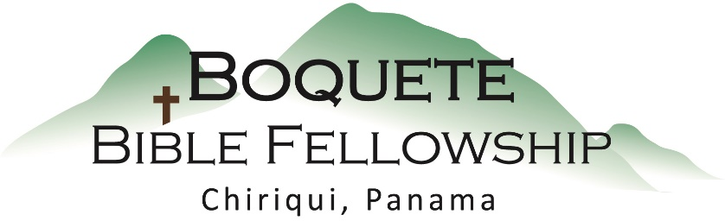

Deuteronomy 6:10-12 New Living Translation (NLT)
¹⁰ “The Lord your God will soon bring you into the land he swore to give you when he made a vow to your ancestors Abraham, Isaac, and Jacob. It is a land with large, prosperous cities that you did not build. ¹¹ The houses will be richly stocked with goods you did not produce. You will draw water from cisterns you did not dig, and you will eat from vineyards and olive trees you did not plant. When you have eaten your fill in this land, ¹² be careful not to forget the Lord, who rescued you from slavery in the land of Egypt.

Psalm 119:16 New King James Version (NKJV)
¹⁶ I will delight myself in Your statutes; I will not forget Your word.

James 1:22-25 New Living Translation (NLT)
²² But don’t just listen to God’s word. You must do what it says. Otherwise, you are only fooling yourselves. ²³ For if you listen to the word and don’t obey, it is like glancing at your face in a mirror. ²⁴ You see yourself, walk away, and forget what you look like. ²⁵ But if you look carefully into the perfect law that sets you free, and if you do what it says and don’t forget what you heard, then God will bless you for doing it.

Exodus 20:8-11 New American Standard Bible (NASB)
⁸ “Remember the sabbath day, to keep it holy. ⁹ Six days you shall labor and do all your work, ¹⁰ but the seventh day is a sabbath of the Lord your God; in it you shall not do any work, you or your son or your daughter, your male or your female servant or your cattle or your sojourner who stays with you. ¹¹ For in six days the Lord made the heavens and the earth, the sea and all that is in them, and rested on the seventh day; therefore the Lord blessed the sabbath day and made it holy.

Ecclesiastes 12:1 New King James Version (NKJV)
Remember now your Creator in the days of your youth, before the difficult days come, and the years draw near when you say, “I have no pleasure in them.”

Luke 17:32-33 New Living Translation (NLT)
³² Remember what happened to Lot’s wife! ³³ If you cling to your life, you will lose it, and if you let your life go, you will save it.

Sermon Notes – “In remembrance”

1.) Do not forget from ____________________ you ____________________.

2.) Do not forget ____________________ ____________________.

3.) Do not forget what the Holy Spirit ____________________ to you.

4.) Remember to ____________________ from your ____________________.

5.) Remember your ____________________ while you’re still ____________________.

6.) Remember that following Christ is an ____________________ proposition.

