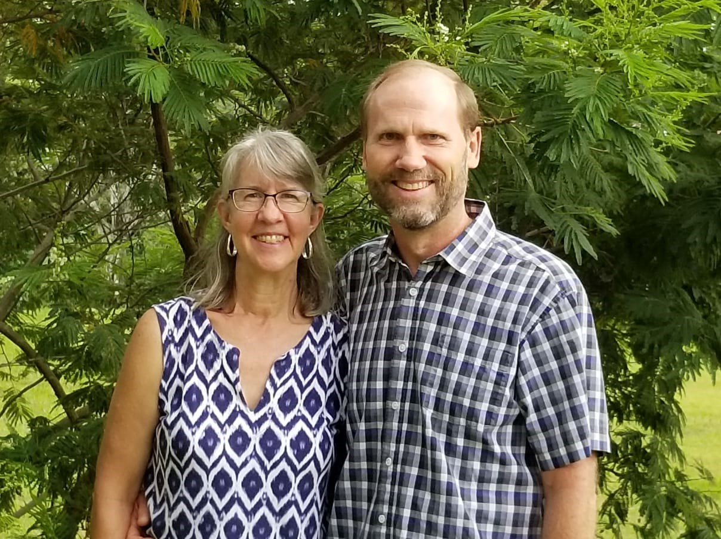
Ministry Name:
The Bridge

Ministry Leader/BBF Contact:
Darrell & Denise Eash

We are Darrell & Denise Eash. We moved to Boquete in 2015 and are amazed at what God has been doing since our arrival. We didn’t come to Boquete as missionaries, but have since been given a heart to come alongside our brothers and sisters in Christ to encourage them in their spiritual journey by discipling them and spurring them on toward love and good deeds (Hebrews 10:24). With Darrell’s ability to communicate in Spanish, we are able to minister in both languages. This opens up many doors of opportunity with our neighbors down the street, other local Panamanians, Ngobe families in the area, Latinos from other countries, the North American expat community, and anyone else who has made the western end of Panama their home. This country is truly a bridge to the world, as it is often called.

There are several areas of discipleship we focus on:

Leading Bible Study Groups: The most important thing we do is encourage in-depth Bible study, so that others can learn how to study and interpret the Bible for themselves. By immersing ourselves in God’s Word and developing a deeper relationship with each member of the Trinity, God begins to renew our minds, transform our lives, and fulfill the plans and purposes He created for us before the foundation of the world. Each group participant is asked to complete a daily study on their own and then to share at the weekly group meeting the truths they discovered during their personal time with the Lord. There’s also ample opportunity to ask questions for further understanding. We’ve found that small groups not only allow the members to learn from each other, but also to explore the practical application of Biblical truth into their own lives. This is how the early Church was able to grow so rapidly in spite of the intense persecution they faced. They developed small communities of believers that met regularly in homes for fellowship and teaching. With weekly study and discussion groups, we hope to nurture the maturing process of each person’s faith, while at the same time instilling a sense of family love and unity.

We have a variety of groups we’re leading with this focus in mind:
-BBF Sunday morning meeting of Spanish-speaking members
-Spanish mentoring on Saturday mornings at BBF
-Spanish Bible study on Saturday nights in Palmira neighborhood
-Women’s Bible study in English on Wednesday afternoons
-Women’s online Bible study in English by videoconference

Raising Up Leaders: We are always looking for leaders that we can train and encourage to start a Bible study of their own, once they are ready to do so. The work of reproducing ourselves is a key ingredient of discipleship. The Apostle Paul told Timothy to entrust his teachings to faithful men who would be able to teach others also (2 Timothy 2:2). By doing this, we can create a network of small groups connected to each other and to us, much like the “churches of Galatia” or the “saints in Philippi”. Jesus modeled this approach with His own disciples as He taught them to advance the kingdom of heaven on Earth.

Providing Workshops: Darrell offers workshops and seminars on a variety of topics, such as marriage and parenting. These are available wherever the Lord calls us and as He provides the funds, including other countries in Latin America where we’ve received invitations to speak. Darrell is also coming alongside ministries like Insight for Living, helping to open doors here in Panama for the training of pastors and lay leaders in how to study God’s Word and teach others to do the same. Local workshops are a wonderful option for those who might not have the time or financial resources to attend a seminary or Bible school.

Assisting Short-term Mission Groups: We assist in planning, organizing, guiding, and interpreting for short-term mission teams that are focused on evangelism and meeting people’s physical and spiritual needs. Because of our cultural understanding and knowledge of different ministries here in Panama, we can connect teams with the outreach opportunities that best fit their gifting and calling. Short-term mission trips are not only a valuable way to serve Christ overseas, but also help team members gain a better perspective of what God is doing in other parts of the world and the role they play in that work.

Translating for Other Missionaries/Ministries: Since Darrell grew up in Venezuela and has been involved with Spanish translation for over 30 years, much of the help we provide to other missionaries and ministries is language related. He translates for sermons, events, outreaches, or whatever meetings need his assistance. This includes weekly translation of the Sunday morning service for BBF’s Spanish-speaking members, as well as participation in God’s Eyes clinics and monthly community prayer gatherings.

Darrell & Denise Eash

Email: thebridgepanama@outlook.com

Panama Cell Number: +507 6587-7167

U.S. MagicJack Number: 719-598-8507

Facebook: The Bridge, Panama

