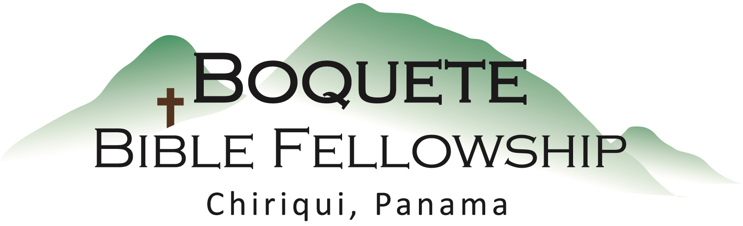

Psalm 16 ESV (English Standard Version) & NASB

Preserve me, O God, for in You I take refuge.
² I say to the Lord, “You are my Lord;
I have no good apart from You.”
³ As for the saints in the land, they are the excellent ones,
in whom is all my delight.
⁴ The sorrows of those who run after another god shall multiply;
their drink offerings of blood I will not pour out
or take their names on my lips.
⁵ The Lord is my chosen portion and my cup;
You hold my lot.
⁶ The lines have fallen for me in pleasant places;
indeed, I have a beautiful inheritance.
⁷ I bless the Lord who gives me counsel;
in the night also my heart instructs me.
⁸ I have set the Lord always before me;
because He is at my right hand, I shall not be shaken.
⁹ Therefore my heart is glad, and my whole being rejoices;
my flesh also dwells secure.
¹⁰ For You will not abandon my soul to Sheol,
or let your holy one see corruption.
¹¹ You make known to me the path of life;
in Your presence there is fullness of joy;
at Your right hand are pleasures forevermore.

Sermon Notes – Psalm 16 – Part 1

David uses declaring and exulting in what and who God is for him as a means of strengthening his hope and confidence in the Lord.

God is our greatest and safest refuge.

God is our Sovereign, our Master, our Lord [Adonai], and our supreme Treasure.

God is good, gracious and merciful toward us.

God is our glorious and beautiful Counselor.

